ECA05-Engineering Electromagnetics
Date:
Transformation between Cartesian, Cylindrical and spherical coordinate system
Aim:
To write program for Transformation between Cartesian, Cylindrical and spherical coordinate system using SCILAB.
Software required:
•SCILAB version 6.0.1
Theory:
Program:
Test case (i) Transformation of Cartesian coordinate points in to Cylindrical and spherical
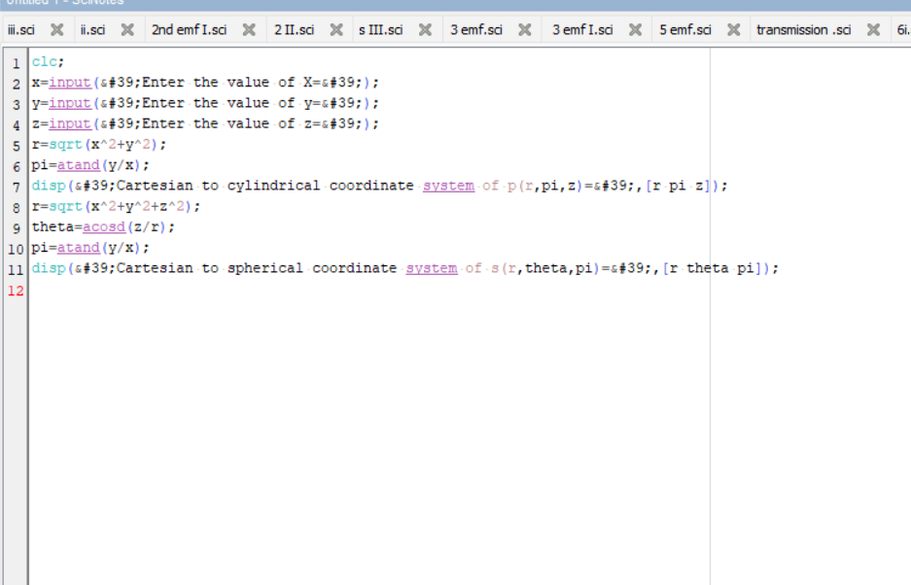
coordinate system

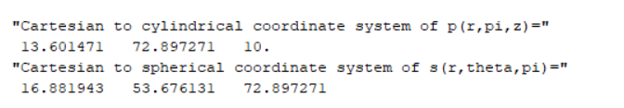
Output:-
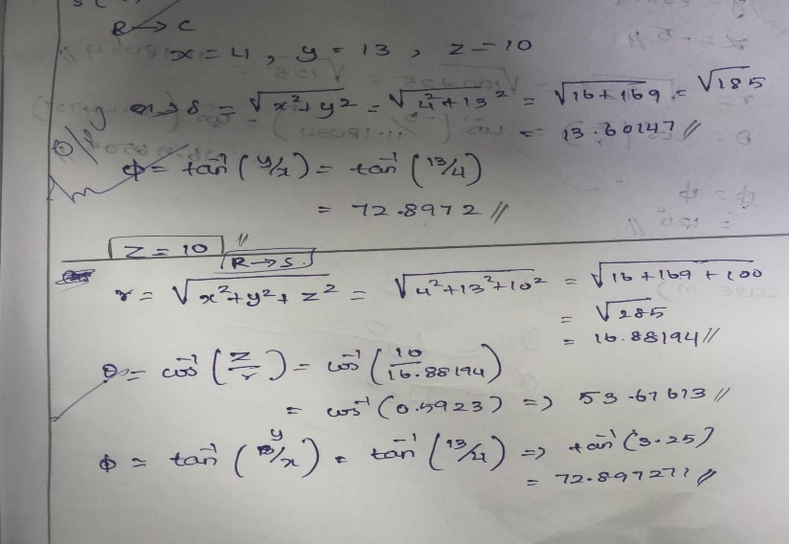
output:

case ii)
Test case (ii) Transformation of Cylindrical coordinate points into Cartesian and spherical coordinate system
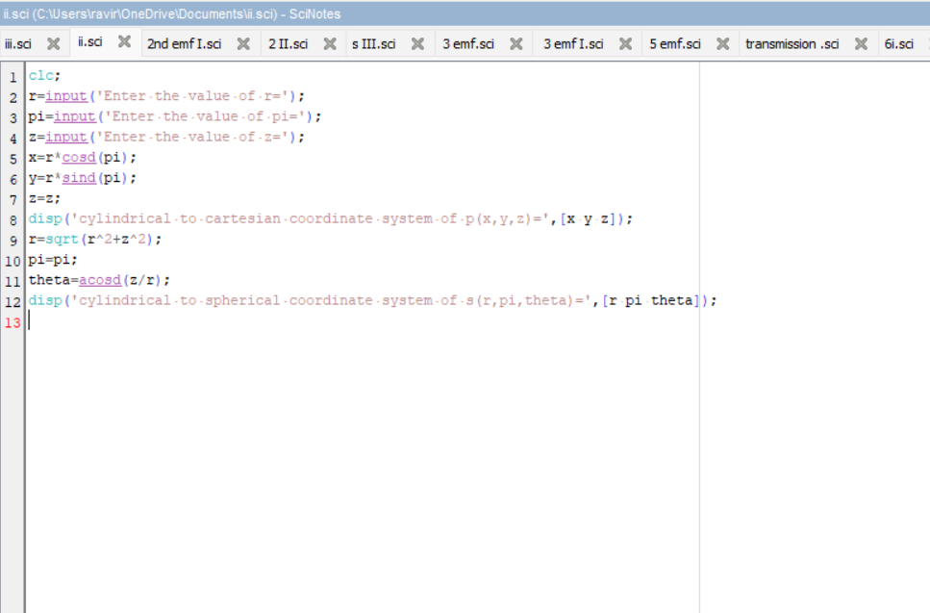

Output:
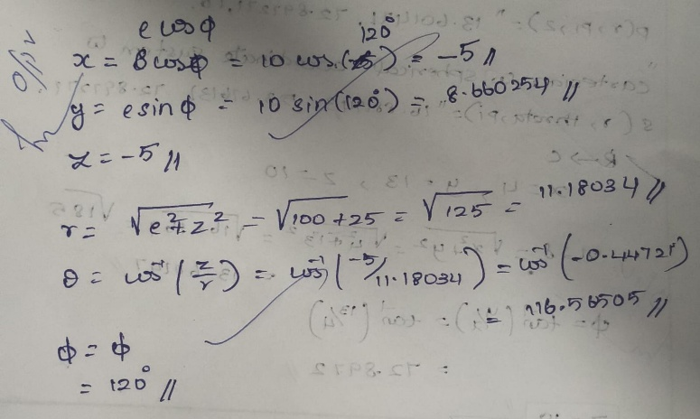
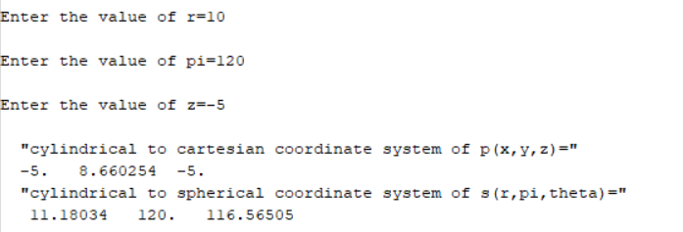

Test case (iii) Transformation of spherical coordinate points into Cylindrical and Cartesian coordinate system
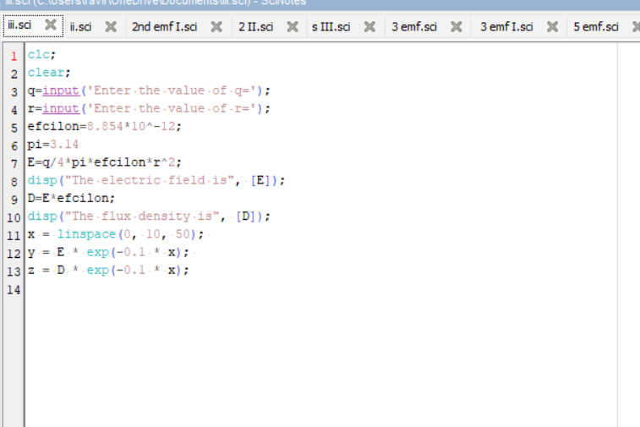

output:
